**Text Manipulation and the Text Content Property**

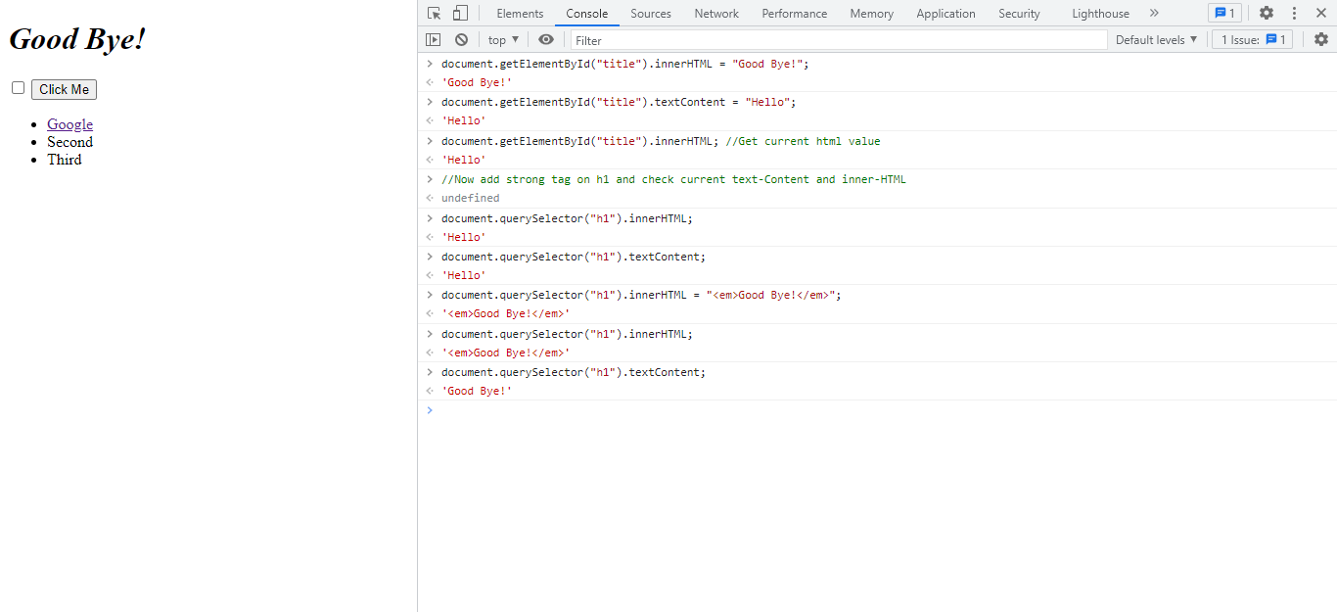

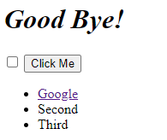

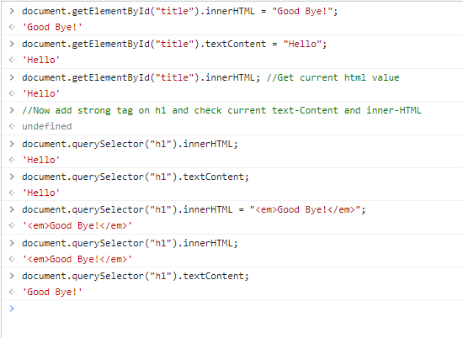

**Code:**

HTML:

<!DOCTYPE html>

<html lang="en" dir="ltr">

<head>

<meta charset="utf-8">

<title>My Website</title>

<link rel="stylesheet" href="css/styles3.css">

</head>

<body>

<h1 id="title"><strong>Hello</strong></h1>

<input type="checkbox">

<button class="btn invisible" style=":active: color:red;" >Click Me</button>

<!-- Add list -->

<ul id = "list">

<li class="item">

<a href="http://www.google.com">Google</a>

</li>

<li class="item">Second</li>

<li class="item">Third</li>

</ul>

<script src="index3.js" charset="utf-8"></script>

</body>

</html>